TULLETT – Millennium IT Exchange

Amendment Record

Issue No. | Amendment No. | Date | Reason for Change | Change implementer
1 | 1
1 | 2

Version | Author | Date | Description
1.0 | Asanka D |  | DRAFT

Version Control

This document describes the actions needed to failover systems from the Primary Data Centre (PDC) to the Secondary Data Centre (SDC).

Acronym | Description
DB | Database
DR | Disaster Recovery
BSR | Backup Site Recovery
PDC | Primary Data Centre (Bromley site)
SDC | Secondary Data Centre (Bishopsgate site)
MIT | Millennium IT
MIT-X | Millennium IT Exchange
EOD | End Of Day
SOD | Start Of Day

Contents

1. Summary 3
1.1. Steps to move from PDC to SDC (Bishopsgate site) 3
1.2. Rollback to PDC (Bromley site) 3
2. Controlled BSR Invocation 4
2.1. Invocation – phase 1 4
2.2. Invocation – phase 2 6
3. Controlled BSR Revocation 7
3.1. Revocation – phase 1 7
3.2. Revocation – phase 2 7

Summary

Steps to move from PDC to SDC (Bishopsgate site)

Scenario - Primary site crashes during trading hours. (Total outage of the primary site.)

- Following sequence of steps should occur during a rollover from PDC to SDC.
Note - The primary application instance of tpIRS is running in Bromley while the backup instance is running in Bishopsgate.

- Login to SDC management server.
- Shutdown processes which are running on both primary site and backup site.
Note - Primary site access is required to shutdown the primary site processes.
- Switchover primary site Oracle DB to the backup site using Oracle Dataguard and start the DB.
- Change environment variables of the production user to reflect the DR site.
- Run the machine switch SQL to move all the processes to run in the DR site.
- Change the DB Alias (all tpIRS DB schemas) and environment files to DR Site
- Start tpIRS back-end processes (after assigning them to the DR Site)
- After backend is started up, login to SysGuard FE and disable “Auto Firing Events”.
- Verify the process CPU affinity schemes through SysGuard FE.
- Run the start sequence “Check Point for system recovery”.
- Once the previous sequence is completed, run the backup site startup sequence (PTTPS,PTGW will be Salvagestarted).
Note -This sequence will recover only the trades in the system.
These trades (TCRs) can be viewed from Service Desk using a Trade Capture Query. The backup site does not support local failover of processes as only the primary instance of a process will be started.

- Do a start of day through MarketManager FE.
- Open markets manually and continue with trading.
- Close markets manually after the trading time is passed.
- Complete the EOD/SOD procedure in the defined time period.

Rollback to PDC (Bromley site)

- Following sequence of steps should occur during a rollback from PDC to SDC.

- Switchover Oracle DB from DR site to Primary site using Oracle DataGuard.
- Execute the machine switch SQL to move all the processes from DR site to Primary site.
- Change the DB Alias and environment variables back to the primary site.
- Start the backend processes from primary site.
- Verify the global value NEXT_TRADING_DATE is updated correctly.
- Verify affinity schemes and the events are set properly.

Controlled BSR Invocation

The section describes the schedule of events or procedural steps which need to be followed in order to invoke BSR from PDC onto SDC.

Once the MIT database is available in the SDC, the steps below are needed to get MIT-X started from cold to warm state:

Invocation – phase 1

Seq | Description of Event/Action | Comment | Estimated Duration
I1 | Verify that DBA’s have completed RMAN backup. Then proceed to the next step. | CRITICAL
12 | On the SDC Management Server Source the TP_env file on all shells that you’re working from. | On the SDC Management Server Source the TP_env file.
I3 | Execute the script ”tpex backupdb SG” separately  from SDC Management Server.
I4 | Execute tpMachineSwitch SQLfrom SDC Management Server to move all the processes to run on DR site | SQL has been created to do this update
I5 | Execute ‘tpex shutdown’ script from SDC Management Server. | This is part of MIT operational script, already available.
I6 | Execute ‘tpex checkhealth’ script from SDC Management Server | This is part of MIT operational script, already available.
I8.a | Verify that $SYSTEM_DATA/AsyncLogger of :  Primary one contains following empty files.  1. ATSD_EXE_EXE_REPORT_1_1_1  2. ATSDN_EXE_EXE_REPORT_ 1_1_1  Mirror contains following empty files.  1. ATSD_EXE_EXE_REPORT_1_1_2  2. ATSDN_EXE_EXE_REPORT_1 _1_2 | These files are required by AsyncLogger during the start-up.
I9.b | Execute ‘tpUpdateDBAlias.pl ’ script from SDC Management Server to set the SDC DB Alias. | Script Updates the following ALIAS in SysGuard Global configs.  ATS_ALIAS : <DR_Site>  CHKPT_ALIAS : <DR_Site>
I10.a | Execute ‘tpex start’ script from SDC Management Server to start the system backend.
I10.b | Disable SysGuard Auto firing Events | SysGuard Front end → Run → Events  <Dissable Automation>
 | Set the Auto Advance Mode to FALSE on MarketManager. | This is to stop Automatic trigger of market activities.
 | Verify the affinity scheme of SDC environment
I10.c | Login to SysGuard front-end and set the SysGuard flag FLAG_STAGGERED_START to STARTED state.
I12 | Run “Checkpoint for System Recovery” Sequence from SysGuard front-end.
I13 | Wait till FLAG_SYSTEM_CHECKPOINT is set to DONE state. | Proceed to the next step once it’s completed.
I14 | Run “System Start - Backup Site Recovery Sequence. Wait till STARTUP_SEQ is set to DONE and proceed to next step. | This sequence will Salvage START PTTPS,PTGW,DMS GW  This sequence will recover all trades in the system.  Note: - There could be a TCR loss depending on the severity of network outage during a disaster.
I15 | Login to MarketManager front-end click on ‘Start Day’ button. Verify that Value of system date config is Current Date. Click 'Start'
I17 | Verify that FLAG_SPN is RESET ; then proceed to the next step.
 | Since SysGuard Automation is DISABLED none of the SysGuard events will be fired automatically. It will be too risky to ENABLE it hence please manually trigger these activities through SysGuard front end depending on the time at which the DR was invoked.

Invocation – phase 2

If the failure was to occur during Trading hours, the logic would be to finish off the End Of Day (EOD) activities in SDC before considering going back to PDC. The obvious point of recovery is during the MIT “System Maintenance / Upgrades” window as shown in the diagram below.

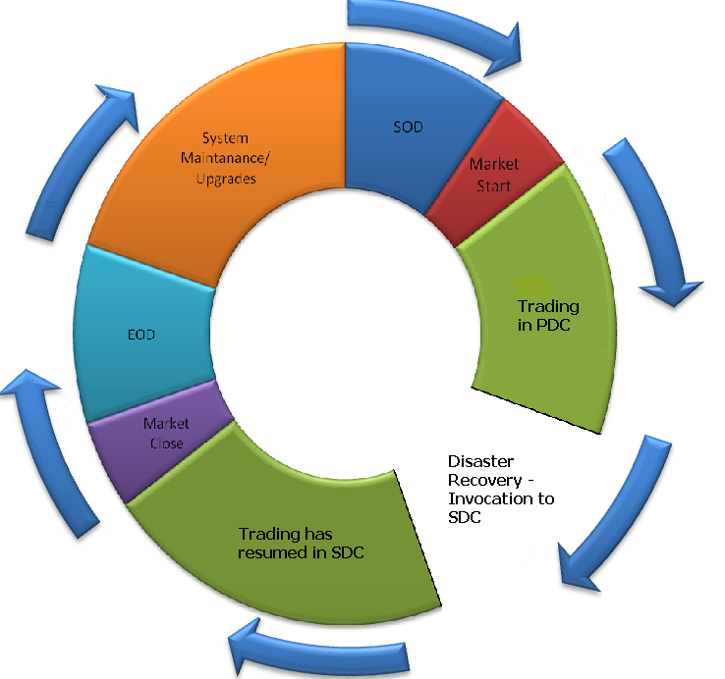

Once the Markets have been closed, the EOD activities need to resume (potentially triggered manually due to failure), as of:

Seq | Description of Event/Action | Comment | Estimated Duration
I17 | EOD should automatically fire at the defined EOD time, but if the Session is extended beyond EOD time Login to MarketManager front-end and click on ‘End Day’ button and send the END day signal. | End Market, End Day must be clicked. 5ES message needed by downstream systems.
I18 | Wait till FLAG_END_OF_DAY status change to DONE and then proceed to the next step.
 | Follow up the complete EOD procedure on the DR Site
I28.a | Execute the following commands separately from SDC Management Server  ‘tpex collectfiles LOGS’  ‘tpex collectfiles DATA’  ‘tpex collectfiles COREFILES’ (this can be ignored if there are no cores created during the day) | This is part of MIT operational script, already available.  This will backup logs, data, corefiles and tmp folders.
I29.a | Execute ‘tpex cleansystem ALL’ from SDC Management Server | This will clean logs, data, corefiles and tmp folders.
Execute the following script is revocation is carried out
I29.b | Execute ‘tpMachineSwitch’ script from SDC Management Server. | This script will restore the PDC process distribution.
 | Point the TP_env file to PDC environment to run on the primary site
 | Set the DB Alise back to the Primary site

Controlled BSR Revocation

The section describes the schedule of events or procedural steps which need to be followed in order to revoke BSR from SDC back to PDC.

Revocation – phase 1

Please note that if you are looking at simulating a disaster by splitting PDC from SDC, the PDC platform would have been left running as a result you ought to look at shutting down PDC applications before considering enabling once again the synchronisation path PDC -> SDC.

Seq | Description of Event/Action | Comment
R1 | Shut down PDC MIT services

Revocation – phase 2

Once the MIT database is available in the PDC again, the steps below are needed to get MIT-X reconfigured and ready for next Start Of Day (SOD):

Seq | Description of Event/Action | Comment
R1 | Execute ‘tpex shutdown’ script from PDC Management Server
R2 | Verify that DBA’s have switched the data base back to PDC, Synced the data base and enabled Data Guard.
R3 | Verify that TP_env file is pointed correctly and data base connection is working.
R4 | Execute following from PDC Management Server  ‘tpex collectfiles LOGS’  ‘tpex collectfiles DATA’  ‘tpex collectfiles COREFILES’ (only if processes crashed)
R5 | Execute ‘tpex cleansystem ALL’ from PDC Management Server | This is part of MIT operational script, already available.
R6 | Verify that $SYSTEM_DATA/AsyncLogger of :  Primary one contains following empty files.  1. ATSD_EXE_EXE_REPORT _1_1_1  2. ATSDN_EXE_EXE_REPORT_1 _1_1  Mirror contains following empty files.  1. ATSD_EXE_EXE_REPORT_1_1_2  2. ATSDN_EXE_EXE_REPORT_1_1_2 | These files are required by AsyncLogger during start-up.
R7 | Execute ‘tpex checkhealth’ script from PDC Management Server
R8 | Execute ‘tpUpdateDBAlias.pl ’ script from SDC Management Server to set the SDC DB Alias.  This can be done by a script or manually | Script Updates the following ALIAS in SysGuard Global configs.  ATS_ALIAS : <Primary>  CHKPT_ALIAS : <Primary>
R9 | Execute ‘tpSetMMAutoAdvance.pl TRUE script from SDC Management Server to Set the Auto Advance Mode to TRUE. | This is to ENABLE Automatic trigger of market activities.
R10 | Execute ‘tpex start’ script from PDC Management Server to start the system backend.
R11 | Verify that NEXT_TRADING_DAY SysGuard global config contains the correct next trading date.
R12 | Verify through SysGuard front-end that all PDC and SDC Machines are displayed correctly.  Also Instance Status column of all process instances and admin instances should have “NOT RUNNING” for all instances.  As an additional verification step view the SysGuard audit trail to see if activities done on the SDC site are displayed.
R13 | Verify that FLAG_SPN are in DONE state and all other flags are in RESET state.
R14 | Execute ‘tpex shutdown’ script from PDC Management Server

